FINANCIAL TRANSACTIONS & LOANS DASHBOARD
Using Microsoft Power BI
Project Report
Submitted By
Name: Shibani Sri. U
Register number: E25FA042
Course: B.com Fintech and Ai
Tool Used: Microsoft Power BI Desktop
INTRODUCTION:
For this project, I created an interactive Financial Transactions & Loans Dashboard with the help of Microsoft Power BI. The project focuses on examining financial transactions, customer accounts, loan information, transaction categories and their monetary values using a financial dataset.
The dashboard provides an overall view of different banking activities, such as Deposits, Payments, Transfers and Withdrawals. It also helps examine account categories, active loans, active accounts, customer information and monthly transaction trends.
The main objective of developing this dashboard is to transform the available financial records into meaningful visual information. Analysing a large amount of financial data manually can be time-consuming. Power BI makes this process easier by presenting important details through KPI cards, charts, tables and interactive slicers.
Different visualisation techniques have been used to represent the information, including column charts, line charts, doughnut charts, horizontal bar charts and summary tables. The dashboard also provides filtering options based on transaction type, account name and year.
Through this project, I aimed to understand how Power BI can be applied to financial data preparation, calculation of important indicators and visual analysis. It also helped me learn how interactive dashboards can make financial information easier to examine and understand.
OBJECTIVES:
The main objectives of creating this dashboard are:
- To analyse financial transactions and their values.
- To monitor the number of active customer accounts.
- To understand the status of different loans.
- To compare transaction activities across different months.
- To identify the most commonly used account types.
- To present important financial information through visualisations.
- To make data analysis easier through interactive filters and charts.

DATASET DESCRIPTION:
The Financial Transactions & Loans dataset contains information related to customer accounts, financial transactions and loan details. It includes different fields that help in analysing transaction activities, account categories and loan status.
The important fields available in the dataset are:
Field Name | Description
Account Type | Specifies the category of the customer account.
TypeName | Represents the name or category of a transaction type.
Status Name | Indicates the current status of a loan or account.
Transaction Date | Shows the date on which a transaction took place.
Month | Represents the month of the transaction.
Year | Indicates the year in which the transaction occurred.
Account Name | Contains the name or identification of an account.
Transaction Count | Represents the number of transactions recorded.
Transaction Value | Shows the monetary value of transactions.
Customer Information | Contains details related to customers.
Loan Information | Provides information about customer loans.

This dataset helps in understanding different financial activities and supports the creation of an interactive dashboard.

DATA PREPARATION USING POWER QUERY:
Before developing the dashboard, I imported the financial dataset into Microsoft Power BI Desktop and reviewed the available information.
Power Query Editor was used to examine the dataset and prepare the necessary fields for analysis. This stage is important because properly organised data helps create meaningful calculations and visualisations.
The following activities were carried out during data preparation:
- Importing Data: The financial dataset was brought into Power BI Desktop for analysis.
- Reviewing Columns: I examined the available fields to understand the information contained in each column.
- Checking Data Types: The data types were reviewed to ensure that numerical, text and date fields were identified correctly.
- Examining Numerical Fields: Transaction Count and Transaction Value were checked because they are required for calculations and comparisons.
- Checking Account Categories: The Account Type field was reviewed to identify the different account classifications.
- Reviewing Loan Status: The Status Name field was examined to understand the available loan categories.
- Checking Transaction Categories: Transaction types such as Deposit, Payment, Transfer and Withdrawal were reviewed.
- Preparing Date Fields: Transaction Date, Month and Year were examined for monthly and yearly analysis.
- Preparing Dashboard Fields: The necessary columns were organised for use in KPI cards, charts, slicers and summary tables.
After reviewing the required information, the dataset was prepared for further analysis and dashboard development.
Other operations, such as removing duplicate records, handling missing values, correcting date formats and applying Trim and Clean, should be mentioned only if they were actually performed.

DATA MODELLING AND RELATIONSHIPS:
Data modelling is an important process in Power BI that helps organise information and establish connections between different tables. The Model View in Power BI is used to create and manage relationships between tables. By connecting related information, users can analyse customer details, account information, loan records and transaction activities together. The data model supports the different analyses included in this project, such as account distribution, loan status comparison, monthly transaction activity and transaction summaries.
Relationships should be established using suitable matching columns so that information from related tables can be connected correctly.
Power BI supports different relationship types:
1. One-to-Many Relationship (1: *)
This relationship is used when one record in a table is associated with several matching records in another table.
2. Many-to-One Relationship (*:1)
This relationship connects multiple records from one table to a single matching record in another table.
3. One-to-One Relationship (1:1)
This relationship is established when one record in a table corresponds to only one record in another table.
The USERELATIONSHIP () function can also be used in DAX when a calculation needs to work with an inactive relationship that already exists in the data model.
These relationships help organise the dataset and support the required analysis in Power BI.

DAX MEASURES:
DAX stands for Data Analysis Expressions. It is a formula language in Power BI that helps perform calculations and create measures from the available data. In this dashboard, DAX measures are used to calculate important financial values and display them through KPI cards, charts and summary tables.
The main measures used in the dashboard are explained below:
6.1 Active Loans
This measure identifies the number of loans that are currently classified under the Active status.
Purpose:
It helps understand how many loans are active and provides an overview of the ongoing loan portfolio.
Dashboard Result: 230 active loans.
6.2 Active Accounts
This measure calculates the number of customer accounts that are classified as active.
Purpose:
It helps identify the total active accounts represented in the financial dataset.
Dashboard Result: Approximately 1,297 active accounts.
6.3 Total Transaction Value
This measure calculates the combined monetary value of the transactions recorded in the dataset.
Purpose:
It provides an overall picture of the financial value associated with the recorded transaction activities.
Dashboard Result: Approximately $122.69 million.
6.4 Total Customers
This measure represents the number of customers included in the dashboard calculation.
Purpose:
It helps understand the size of the customer base covered by the financial dataset.
Dashboard Result: Approximately 1,072 customers.
6.5 Total Transactions
This calculation represents the overall number of transactions recorded in the dataset.
Purpose:
It helps measure transaction activity and makes it possible to compare the number of transactions across different categories.
Dashboard Result: 48,510 transactions.
These measures help present important financial information in a simple numerical format. The exact DAX formulas should be taken from the measures created in the Power BI file to ensure that the calculations match the dashboard.
DASHBOARD VISUALISATIONS:
The dashboard was designed using different visualisation options available in Microsoft Power BI. Each visual represents a particular part of the financial dataset and helps users understand the information more easily.
KPI CARDS
Four KPI cards are placed at the top of the dashboard to display the important financial indicators.
These cards highlight the key financial figures and provide an immediate summary of the dataset.
Active Loans represents the number of loans currently classified as active. Active Accounts displays the number of active customer accounts. Total Transaction Value indicates the combined monetary value of the recorded transactions, while Total Customers represents the customer count.
By displaying these figures together, KPI cards make it easier to understand the important information without having to examine each visual separately.

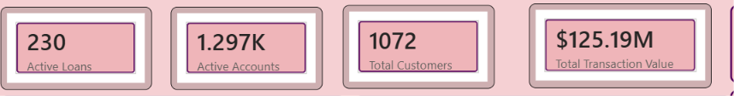
ACCOUNTS BY ACCOUNT TYPE
A column chart titled "Accounts by Accounts Type" is used to compare the number of accounts across five different categories.
The categories displayed are:
- Business
- Youth
- Savings
- Payroll
- Checking
From the chart, Business accounts have the highest representation among the displayed categories. Youth and Savings follow, while Payroll and Checking have comparatively fewer accounts.
Purpose:
- To examine how accounts are distributed among different categories.
- To identify the account type with the highest number of accounts.
- To compare the representation of each account category.
- To understand the overall account distribution.
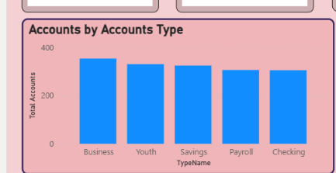
This chart provides a clear visual comparison and helps users identify differences between account categories.

TRANSACTIONS OVER TIME
A line chart titled "Transactions Over Time" is used to display transaction activity across the months from January to December.
The chart indicates that January has relatively high transaction activity, followed by a noticeable decrease in February. During the following months, transaction activity changes at different levels, with a more stable pattern and a slight rise towards December.
Purpose:
- To study the number of transactions recorded during different months.
- To identify periods with higher or lower transaction activity.
- To observe monthly changes in transaction volume.
- To compare transaction patterns throughout the year.
The Year slicer allows users to examine the transaction trend for selected years.
If the dataset contains records from multiple years, the month field should be checked to ensure that the chart displays the intended yearly or monthly comparison.
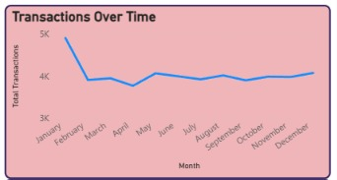

TOTAL LOANS BY STATUSNAME
A doughnut chart titled "Total Loans by Status Name" is used to show the distribution of loans according to their status.
The chart contains three categories:
- Active
- Closed
- Inactive
The displayed chart currently shows approximately 33.33% for each category.
Purpose:
- To examine how loans are divided according to their status.
- To compare the proportion of Active, Closed and Inactive loans.
- To understand the composition of the loan portfolio.
- To present loan information in a simple visual format.
This chart helps users view the distribution of different loan statuses at a glance.
The equal percentages should be checked against the underlying loan records to confirm that the displayed proportions are accurate.
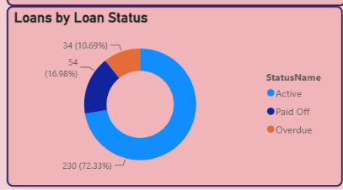

TRANSACTIONS BY TYPE
A horizontal bar chart titled "Transactions by Type" is used to compare the number of transactions under different categories.
The transaction categories and their respective counts are:
Transaction Type | Number of Transactions
Deposit | 14,760
Transfer | 14,478
Withdrawal | 14,412
Payment | 4,860
Total | 48,510
Deposit has the highest transaction count, followed by Transfer and Withdrawal. Payment has the lowest count among the four categories.
Purpose:
- To compare transaction counts across different types.
- To identify the most frequently recorded transaction category.
- To understand the contribution of each category to the total transaction volume.
- To examine differences in transaction activity.
The horizontal bar chart makes it easier to compare the categories and understand their transaction counts.

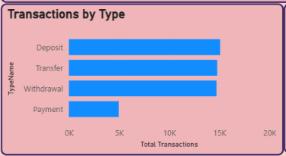

TRANSACTION SUMMARY
The Transaction Summary table provides a detailed presentation of transaction counts and their corresponding monetary values.
The table contains three main fields:
- TypeName
- Total Transactions
- Total Transaction Value
The values displayed in the summary are:
Transaction Type | Total Transactions | Total Transaction Value
Deposit | 14,760 | $37,255,964.91
Payment | 4,860 | $12,293,101.75
Transfer | 14,478 | $36,783,420.00
Withdrawal | 14,412 | $36,360,564.15
Total | 48,510 | $122,693,050.81

This table brings together the number of transactions and the financial value generated by each transaction category. It allows users to compare the monetary contribution of Deposits, Payments, Transfers and Withdrawals in one place. Green data bars are also applied to the Total Transaction Value column. These bars provide a visual comparison of the values, with longer bars representing higher transaction amounts.
This formatting makes the table easier to read and helps users identify differences between transaction categories.
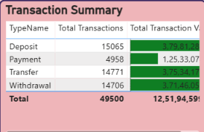

SLICERS AND INTERACTIVITY:
Slicers are interactive filtering tools in Power BI that allow users to view selected information from the dashboard.
Three slicers are included in this project to make the analysis more flexible.
RANSACTION TYPES
The Transaction Types slicer allows users to select a particular transaction category or view all available categories.
By choosing a transaction type, users can examine the corresponding financial information and compare the activities of different transaction categories.
ACCOUNT NAME
The Account Name slicer provides an option to filter the dashboard according to the available account names.
It helps users focus on information related to a selected account and examine the corresponding transaction details.
YEAR
The Year slicer provides year selections ranging from 2020 to 2026.
Users can select a particular year or a range of years to examine transaction activities during the selected period.

VISUAL INTERACTIONS
Power BI also allows different charts and visual elements to respond to user selections. When users select a category or apply a slicer, the connected visuals can filter or highlight the related information according to the interaction settings. The Edit Interactions option can be used to control how one visual affects another visual. These filtering and interaction features allow users to examine the financial information from different perspectives and make the dashboard more convenient to use.
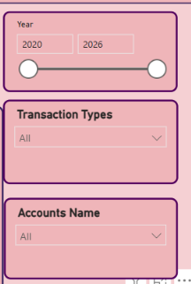

DRILL-DOWN ANALYSIS:
Drill-down is a feature in Power BI that allows users to move from a general summary to more detailed information. For analysing transaction trends, a date hierarchy can be used to explore information at different levels, such as Year, Quarter, Month and Day. The Transactions Over Time chart can be configured with a date hierarchy so that users can examine transaction activity at different levels of detail.
Year Level: Users can view the overall transaction activity for different years.
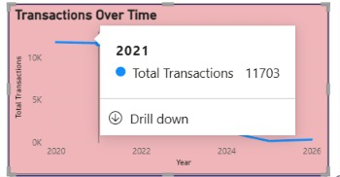
Quarter Level: Users can move further into a selected year and compare transaction activities across its quarters.
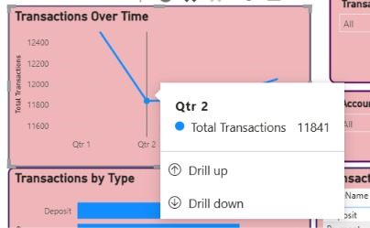
Month Level: Users can examine transaction information for individual months within a selected period.
This feature helps users move between summary-level and detailed information. It also makes it easier to examine changes in transaction activity during selected periods.

REPORT-PAGE TOOLTIP:
A report-page tooltip is a Power BI feature that displays additional information when a user moves the pointer over a data point in a visualisation. A separate report page can be configured as a tooltip page. Additional cards or other visuals can then be added to display information related to the selected data point.
For this dashboard, the tooltip page can provide details such as:
- Transaction Type
- Total Transactions
- Total Transaction Value
When the tooltip is assigned to a chart, users can hover over a particular data point to view the additional information without leaving the main dashboard. This feature provides more detailed information while keeping the main report page organised and easy to understand.
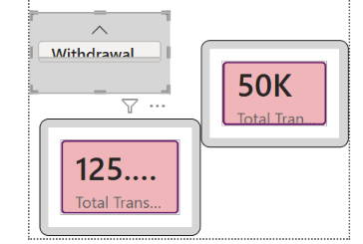

Conditional Formatting:
Conditional formatting is a feature in Power BI that uses visual indicators to make numerical data easier to understand and compare. In the Transaction Summary table, green data bars have been applied to the Total Transaction Value column.
The length of each green data bar represents the relative value of transactions across different categories, including Deposit, Payment, Transfer, and Withdrawal. Categories with higher transaction values display longer bars, while categories with lower transaction values display shorter bars.
From the table, Deposit has the highest transaction value (₹3,79,81,288.32) and therefore displays the longest data bar. Transfer (₹3,75,34,177.40) and Withdrawal (₹3,71,46,059.07) also show long bars because their transaction values are relatively high. In contrast, Payment has the lowest transaction value (₹1,25,33,074.71) and is represented by a shorter bar.
This visual representation allows users to quickly compare transaction values without relying solely on numerical figures. Conditional formatting enhances the overall appearance of the table, improves readability, simplifies comparison, and helps users identify patterns and differences between transaction categories more effectively.
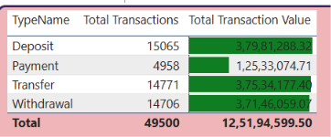

KEY FINDINGS:
After creating and examining the Financial Transactions & Loans Dashboard, I identified the following observations:
- Customer Information: The dashboard displays approximately 1,072 customers.
- Active Accounts: Approximately 1,297 active accounts are represented in the displayed results.
- Loan Details: The dashboard shows 230 active loans.
- Transaction Volume: A total of 48,510 transactions are recorded across the four displayed categories.
- Transaction Value: The combined transaction value is approximately $122.69 million.
- Account Categories: Business accounts have the highest count among the five account categories displayed.
- Monthly Activity: January shows relatively high transaction activity, followed by a sharp decrease in February. The remaining months show variations in transaction volume.
- Loan Distribution: The doughnut chart displays Active, Closed and Inactive loan statuses at approximately 33.33% each.
- Transaction Comparison: Deposit has the highest transaction count, with 14,760 records, whereas Payment has the lowest count, with 4,860 records.
- Financial Contribution: Deposits have the highest transaction value among the four transaction categories, followed by Transfers, Withdrawals and Payments.
- Filtering Options: The Transaction Types, Account Name and Year slicers allow users to explore selected information.
- Visual Analysis: The combination of different charts and KPI cards provide a clear overview of financial activities.
These observations show how the dashboard helps examine financial information, compare transaction categories and understand account and loan details.

CONCLUSION:
The development of the Financial Transactions & Loans Dashboard helped me understand how Microsoft Power BI can be used to organise, analyse and visually present financial information.
Through this project, I created an interactive report that brings together customer details, account information, loan statuses and transaction activities. KPI cards provide a quick summary of important financial indicators, while charts help compare account categories, examine monthly transaction trends and understand loan distribution.
The transaction summary table provides a detailed comparison of transaction counts and monetary values across different categories. Slicers also allow users to filter the available information according to transaction type, account name and year.
I also gained an understanding of important Power BI concepts, including Power Query, data modelling, DAX measures and different visualisation techniques. Features such as drill-down, report-page tooltips and conditional formatting provide additional ways to explore and present the information.
Overall, this project strengthened my practical knowledge of Microsoft Power BI and financial data analysis. It helped me understand how raw financial records can be converted into meaningful visual information and how interactive dashboards make complex data easier to examine and interpret.

